CPU Scheduling Requirement Analysis


BY

Areeba Talib
(Reg. No. 2023-UOK-05)
&
Maham
(Reg. No. 2023-UOK-10)
&
Aila Shoukat
(Reg. No. 2023-UOK-39)

Session 2023-2027

Department of CS/IT
Faculty of Computing & Engineering
University of Kotli Azad Jammu and Kashmir

CPU Scheduling Requirement Analysis

BY
Areeba Talib
Reg. No. 2023-UOK-05)
&
Maham Gulzar
(Reg. No. 2023-UOK-10)
&
Aila Shoukat
(Reg. No. 2023-UOK-39)

A Report
Submitted in partial fulfillment of the requirements for the 5th semester project of

Operating System
In
Information Technology

Session 2023 -27

Department of CS/IT
Faculty of Computing & Engineering
University of Kotli Azad Jammu and Kashmir

Contents
1. Introduction 1
1.1. Objective 1
1.2. Scope 1
2. Requirement Analysis 2
2.1. Functional Requirements 2
2.2. Non-Functional Requirements 2
3. CPU Scheduling Requirement Analysis 3
3.1. Input Requirements 3
3.2. Output Requirements 3
4. Algoritums 3
4.1. FCFS 3
4.2. Round Robin 4
4.3. SJF 4
5. Assumptions 5
5.1. New Features of CPU Scheduling 5
6. Reference 7

Project Proposal
Title: CPU Scheduling Requirement Analysis using FCFS, SJF, and Round Robin

Introduction
The main objective of this project is to simulate and analyze CPU scheduling algorithms in operating systems. CPU scheduling is a core function of the OS, which manages the execution of multiple processes by deciding which process will get CPU time and in what order. This project focuses on three primary scheduling

Objective
algorithms: First Come First Serve (FCFS), Shortest Job First (SJF), and Round Robin (RR). By implementing these algorithms, the project will demonstrate how the choice of scheduling technique affects waiting time, turnaround time, and overall CPU utilization. The project will provide a text-based Gantt Chart to visually represent process execution order.
The objectives of this project are to:
- Simulate multiple CPU scheduling algorithms using C++.
- Calculate and compare performance metrics including waiting time, turnaround time, and average times.
- Provide a menu-driven interface for users to select the desired scheduling algorithm.
- Generate a text-based Gantt Chart to visualize process execution.
- Help students understand the impact of scheduling algorithms on CPU efficiency and process management.

Scope

- Implement and understand FCFS, SJF, Round Robin, Visualize process execution with Gantt charts.
- Calculate Waiting Time, Turnaround Time, Average values.
- Allow real-time input of processes.
- Detect starvation and suggest smart time quantum.

Requirement Analysis

Functional Requirements
- System shall:
- Allow user to enter number of processes
- Take input for:
- Process ID
- Arrival Time
- Burst Time
- Allow user to select scheduling algorithm
- Execute selected CPU scheduling algorithm
- Calculate:
- Waiting Time
- Turnaround Time
- Display:
- Individual process details
- Average waiting & turnaround time
- Generate Gantt Chart for visualization

Non-Functional Requirements
- System should be efficient and fast
- Results should be accurate
- Program should be user-friendly
- Code should be modular & readable
- Error handling for invalid input

CPU Scheduling Requirement Analysis

Input Requirements

- Number of processes
- Process ID
- Arrival time
- Burst time
- Priority (optional)
- Time quantum (for Round Robin)
- Scheduling algorithm selection (FCFS, SJF, Round Robin)

Output Requirements

- Process execution order
- Gantt chart
- Completion time
- Waiting time
- Turnaround time
- Average waiting time and average turnaround time

Algorithms

FCFS

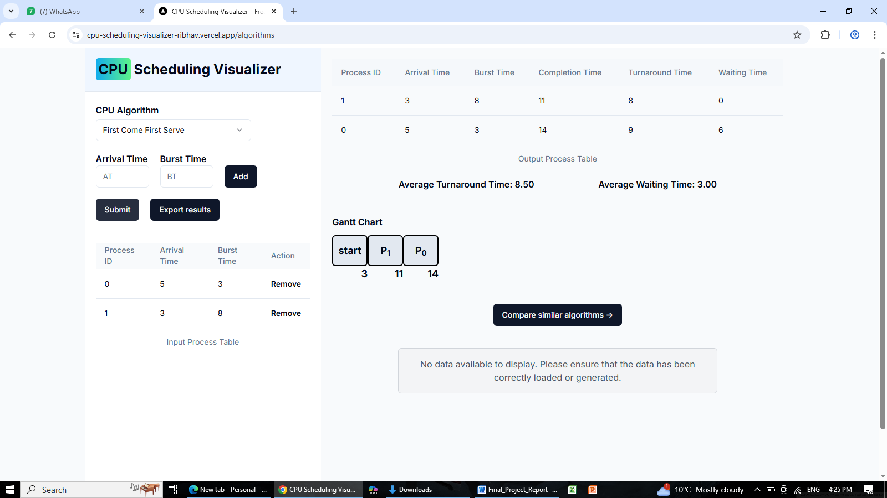

Round Robin
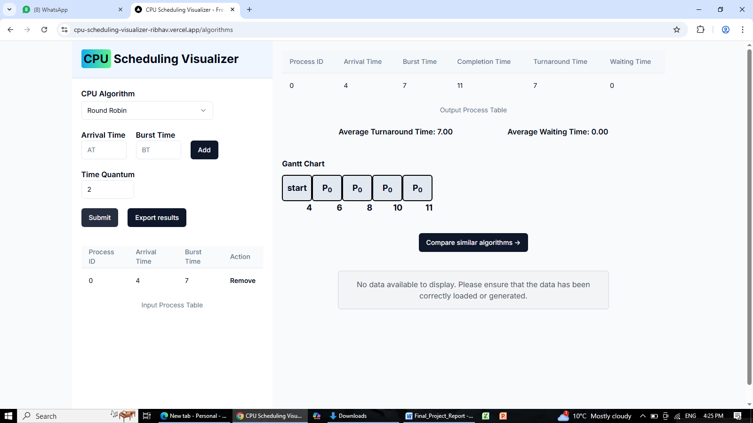

SJF
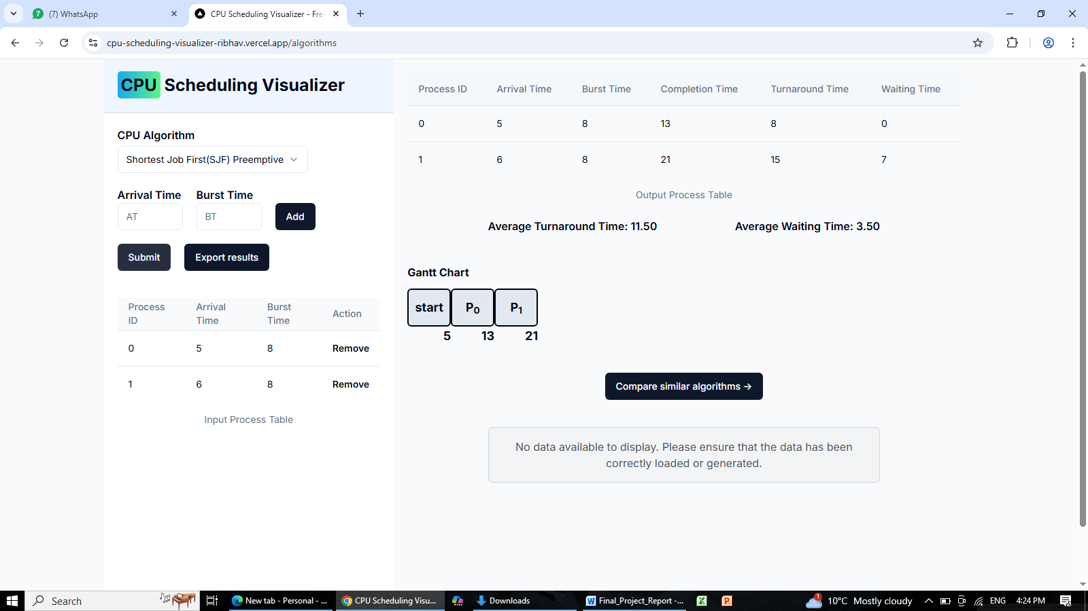

CPU Scheduling Simulator Online
https://cpu-scheduling-visualizer-ribhav.vercel.app/

Assumptions
- Each process works independently.
- The CPU can run only one process at a time.
- The running time (burst time) of each process is already known.
- Processes arrive in the ready queue on time.
- No input/output interruption occurs during execution.
- We ignore context switching time.
- In priority scheduling, smaller number = higher priority.
- In Round Robin, the time quantum is fixed.

New Features of CPU Scheduling

- Dynamic Process Input
Processes can be added during execution to simulate real systems.
- Algorithm Comparison
Compares SJF, Round Robin, and FCFS and shows the best algorithm.
- Step-by-Step Gantt Chart
Displays CPU execution clearly in a visual timeline.
- Smart Time Quantum
System suggests optimal time quantum for Round Robin.
- Starvation Alert
Warns when a process waits too long.
- Clean Modular Design
Separate modules for input, scheduling, and output

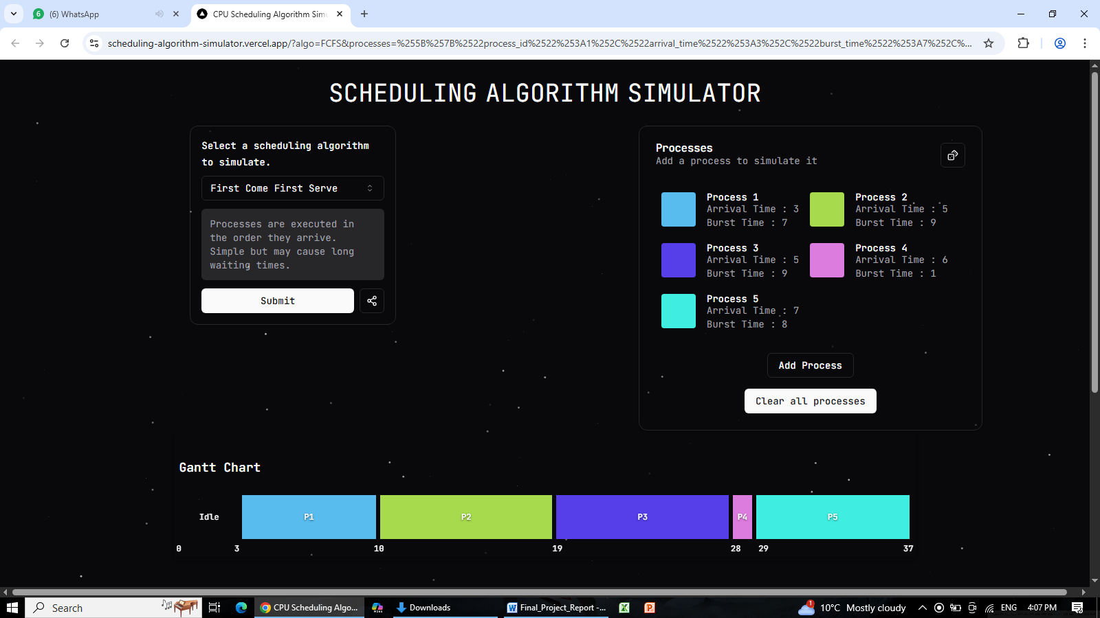

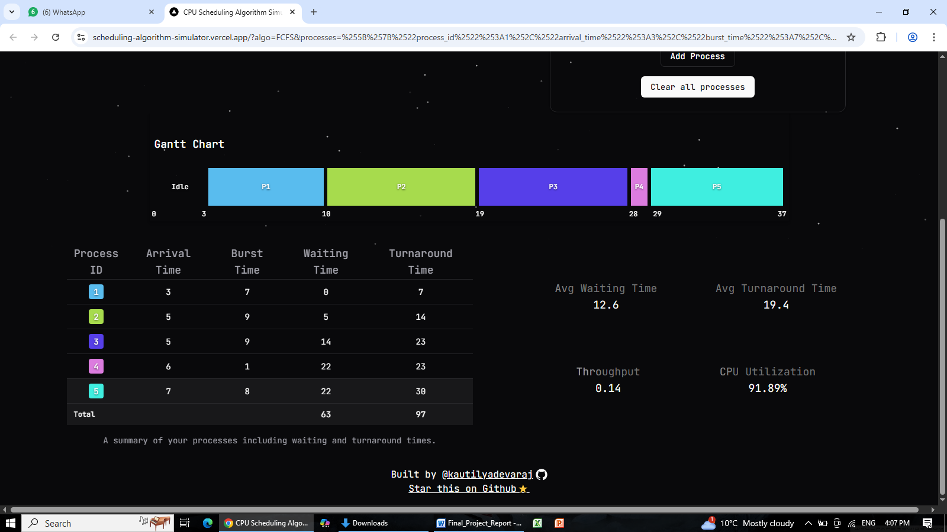

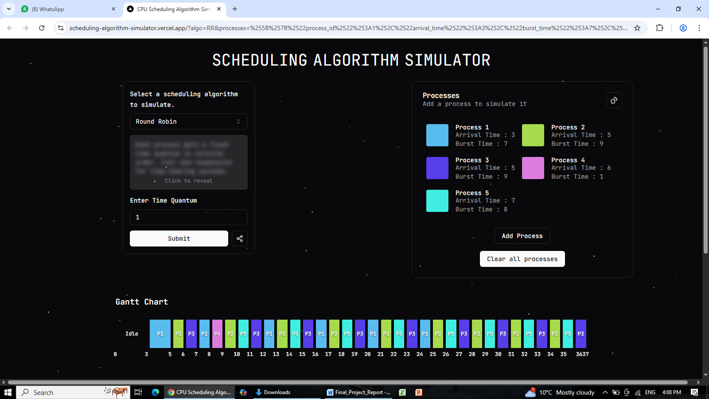
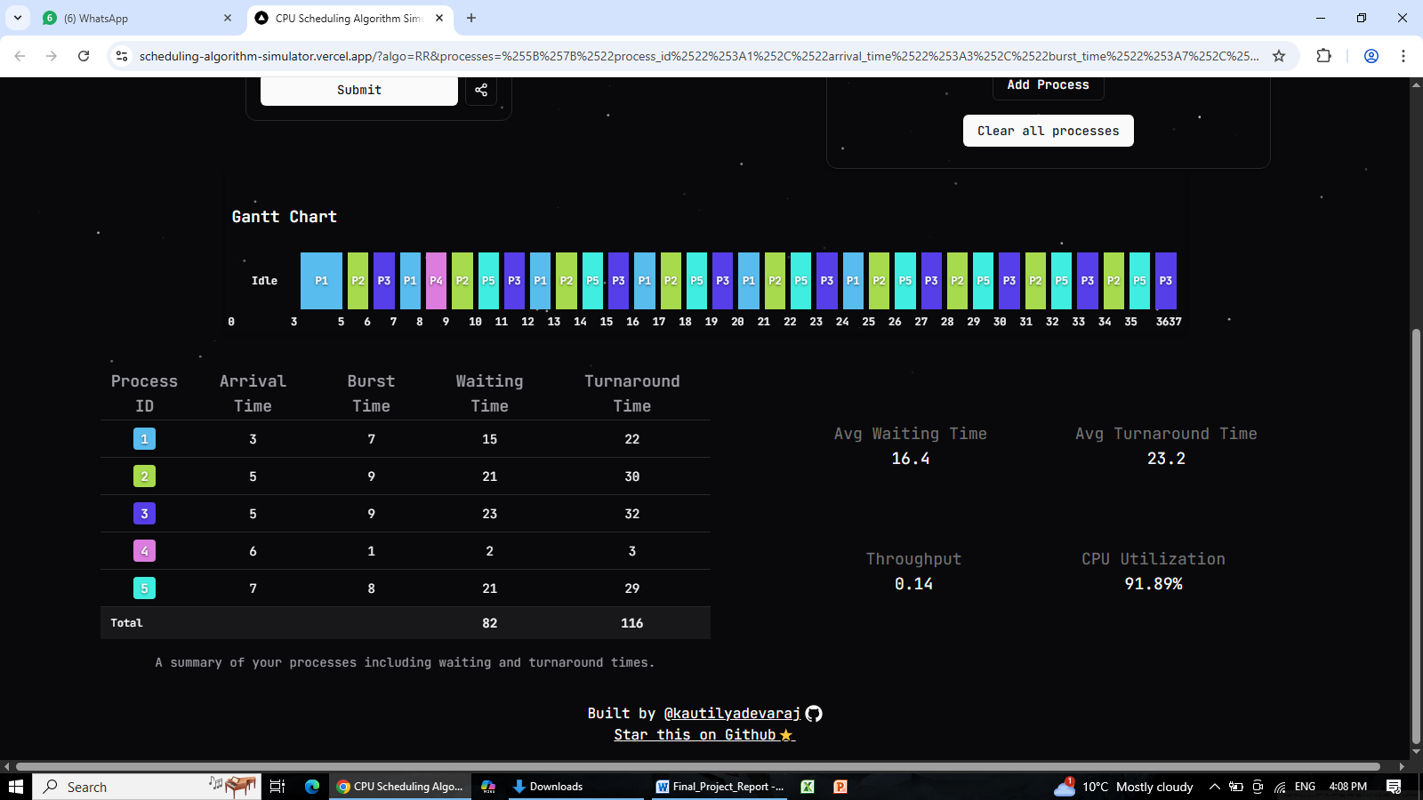

Reference
- CPU Scheduling Tutorial, YouTube, [links]
https://youtu.be/SoLLq7yqojo?si=cx_JHOChnpY34SsE
https://youtu.be/1jLotj5KpVc?si=uMXnGhAeEfR5sCaA https://youtu.be/mIPlAnsPZHU?si=e-by9BAt8hYj3w_H
https://youtu.be/Rf6Ec8PjOyg?si=rl69KfsJLpKJDATi
- We used ChattGPT for guidance and explanation on
CPU scheduling algorithms and simulator features

